Homework Assignment 01

Name: **Asrar Syed**

Due by: **September 18, 2025**

Course Section: **CSC 4222-008**

PART A: CIA Goals Only (20 points)

1. John’s script overloads music servers → Availability.
2. Banking software emails account info → Confidentiality.
3. Maria alters grades → Integrity.
4. James’s password in plain text → Confidentiality.
5. Hospital ransomware → Availability and Integrity.
6. Cloud employees view files freely → Confidentiality.
7. Attacker alters log timestamps → Integrity.
8. Medical record system crashes mid-surgery → Availability.
9. Retailer login only needs email → Confidentiality and Integrity.
10. No audit trail of purchases → Integrity.

PART B: Threats and Attacks (20 points)

1. Alteration.
2. Masquerading.
3. Denial-of-Service (Phase 1), Alteration (Phase 2).
4. Denial-of-Service.
5. Eavesdropping (capture), Masquerading (reuse).
6. Alteration + Repudiation.
7. Masquerading.
8. Correlation.
9. Masquerading + Correlation.
10. Traceback.

PART C: Introduction to Cryptosystem (30 points)

1. 128 ASCII characters, 8-char password
   1. Total = ${128}^{8}≈ 7.2 × {10}^{16}$
   2. Average guess time at 1 ns/test ≈ 36 years
2. GSU password rules (3–5 chars, must include ≥1 digit)
   1. ≈ 916,132,048 possible passwords
   2. At 1.5M/sec and 60% accuracy ≈ 6.1 minutes
3. Password entropy of cybersecurityfall2025

Entropy ≈ 119 bits

1. Barack’s jokes → Digital Signatures (authorship)
2. Alice encrypts with Bob’s public key
   1. Guarantees Confidentiality
   2. Doesn’t authenticate. Solution: digital signature by Alice.
3. DES-like 56-bit key
   1. Keys = $2^{56}≈ 7.2 × {10}^{16}$
   2. Brute force at ${10}^{12}/sec$ ≈ 20 hours

PART D: Ethical Hacking (30 points)

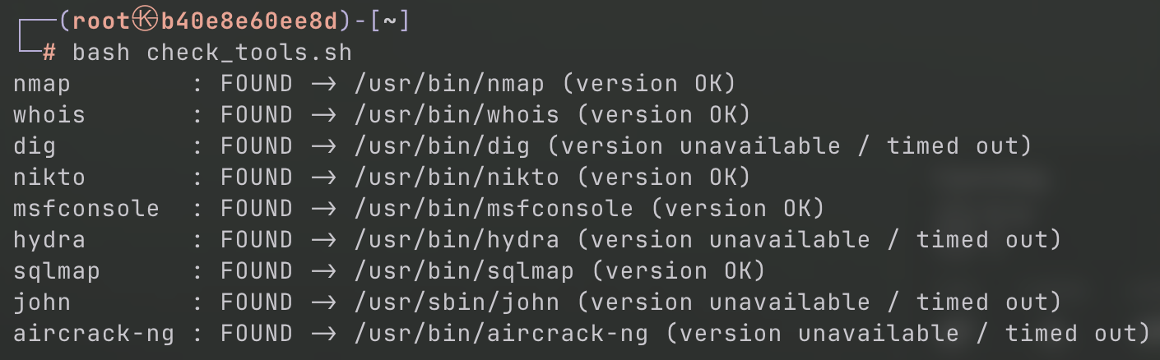

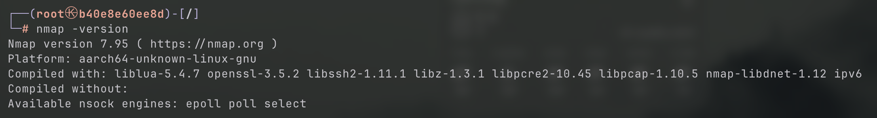

Process 1: Reconnaissance (Information Gathering)

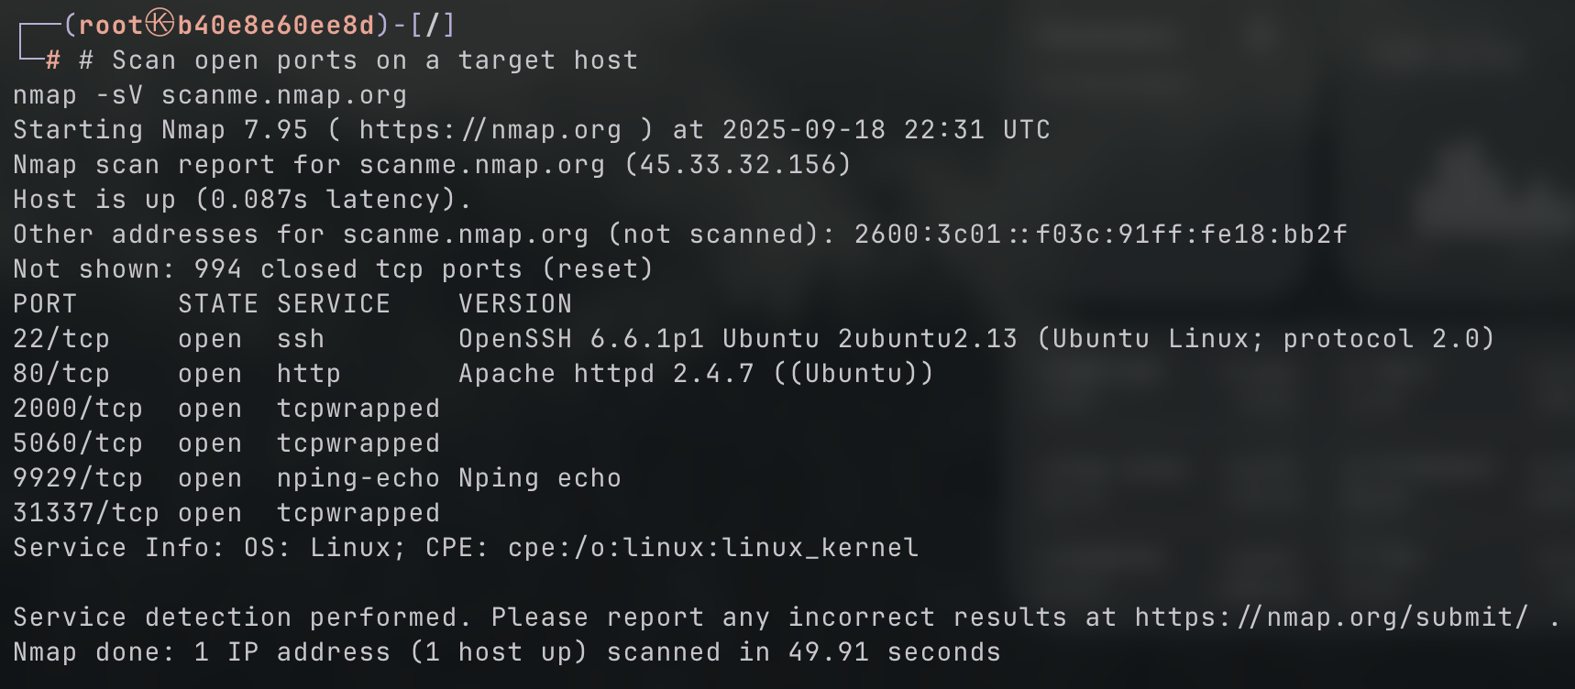

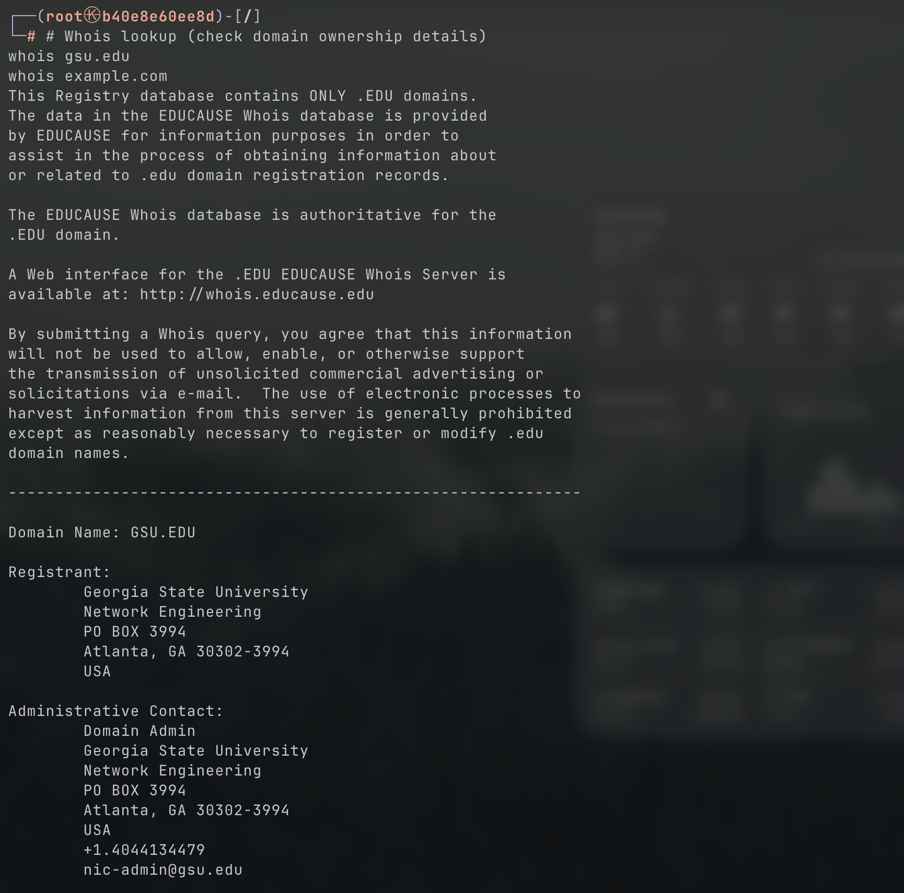

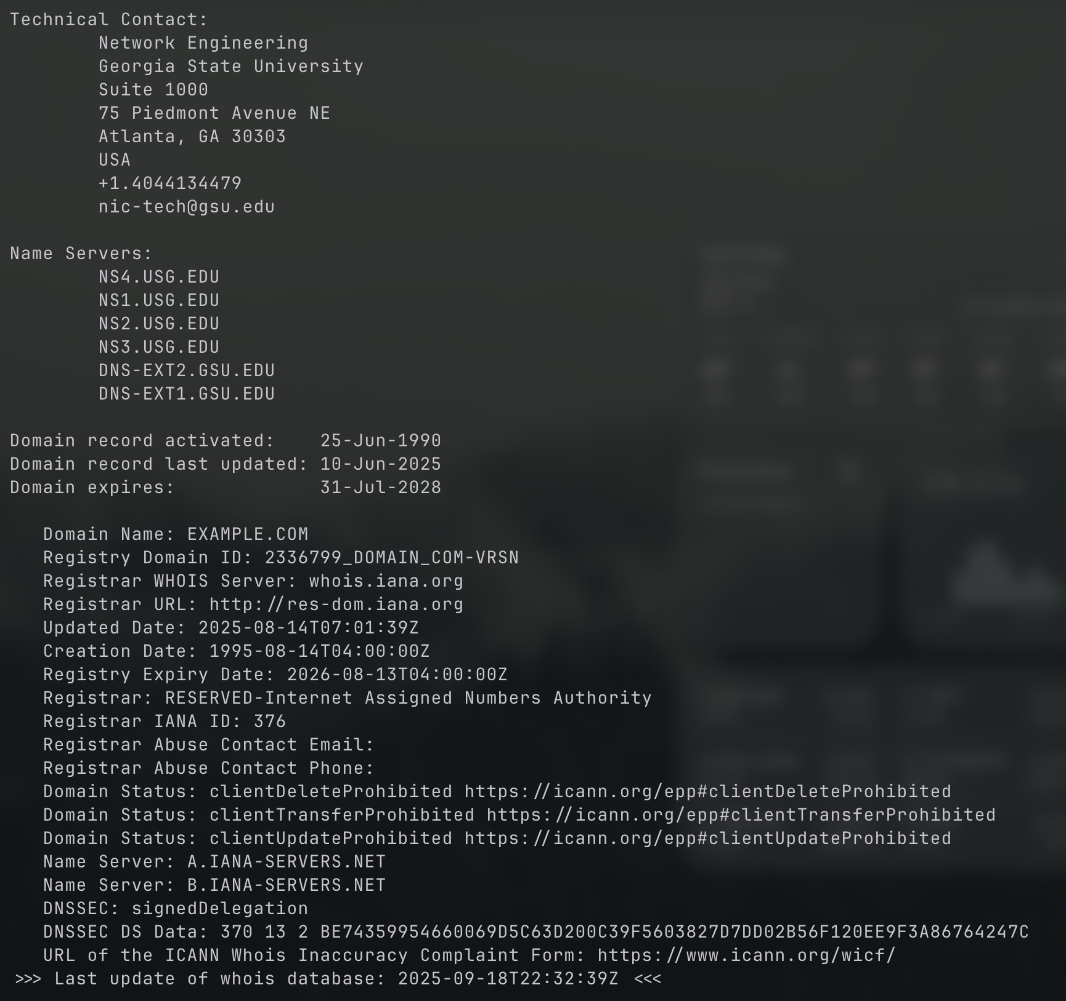

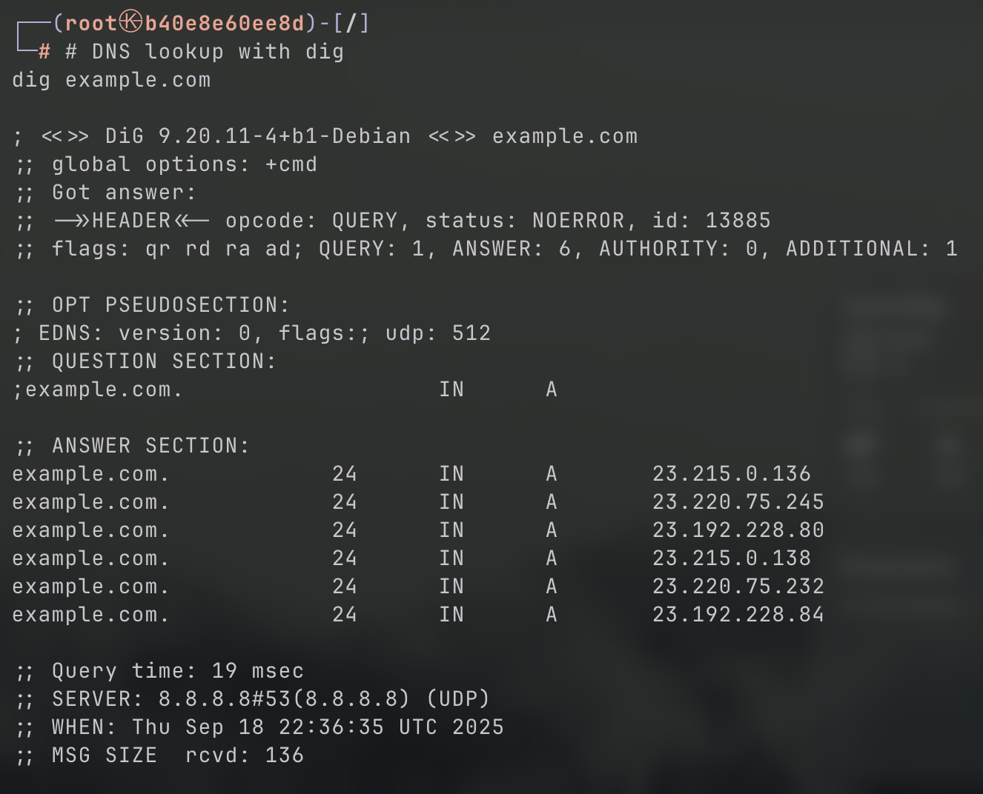

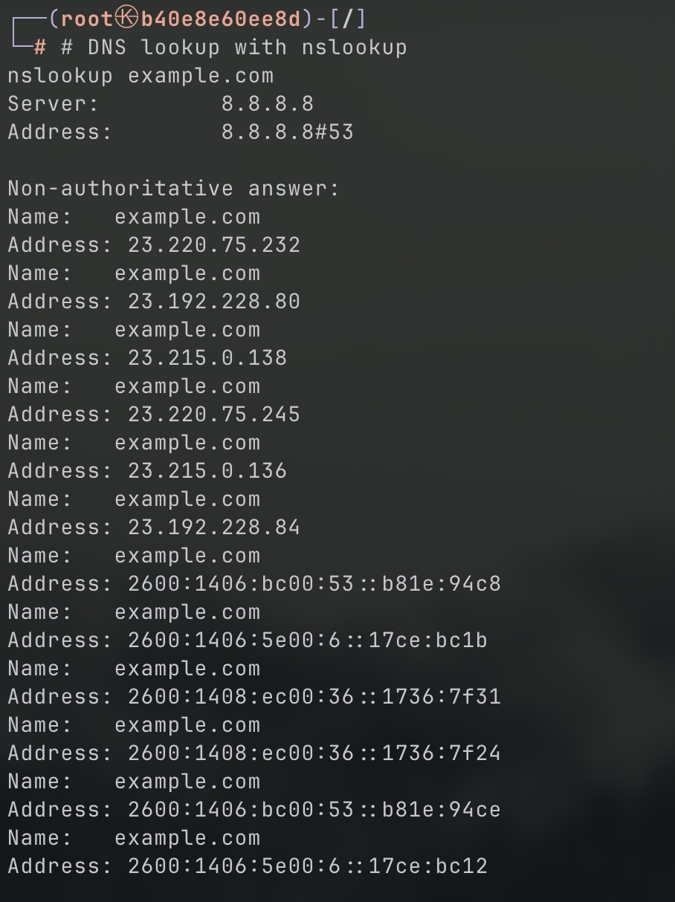

Process 2: Vulnerability Scanning

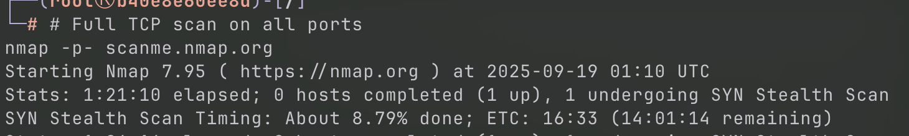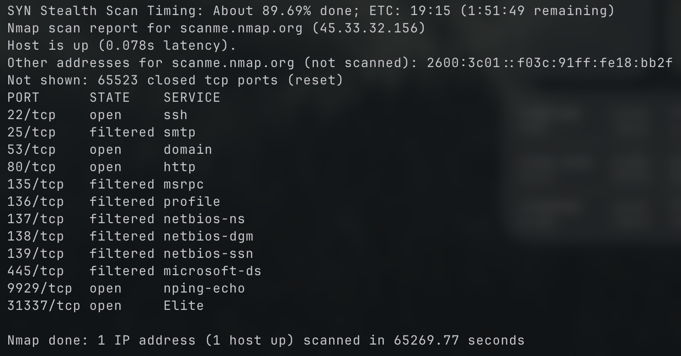

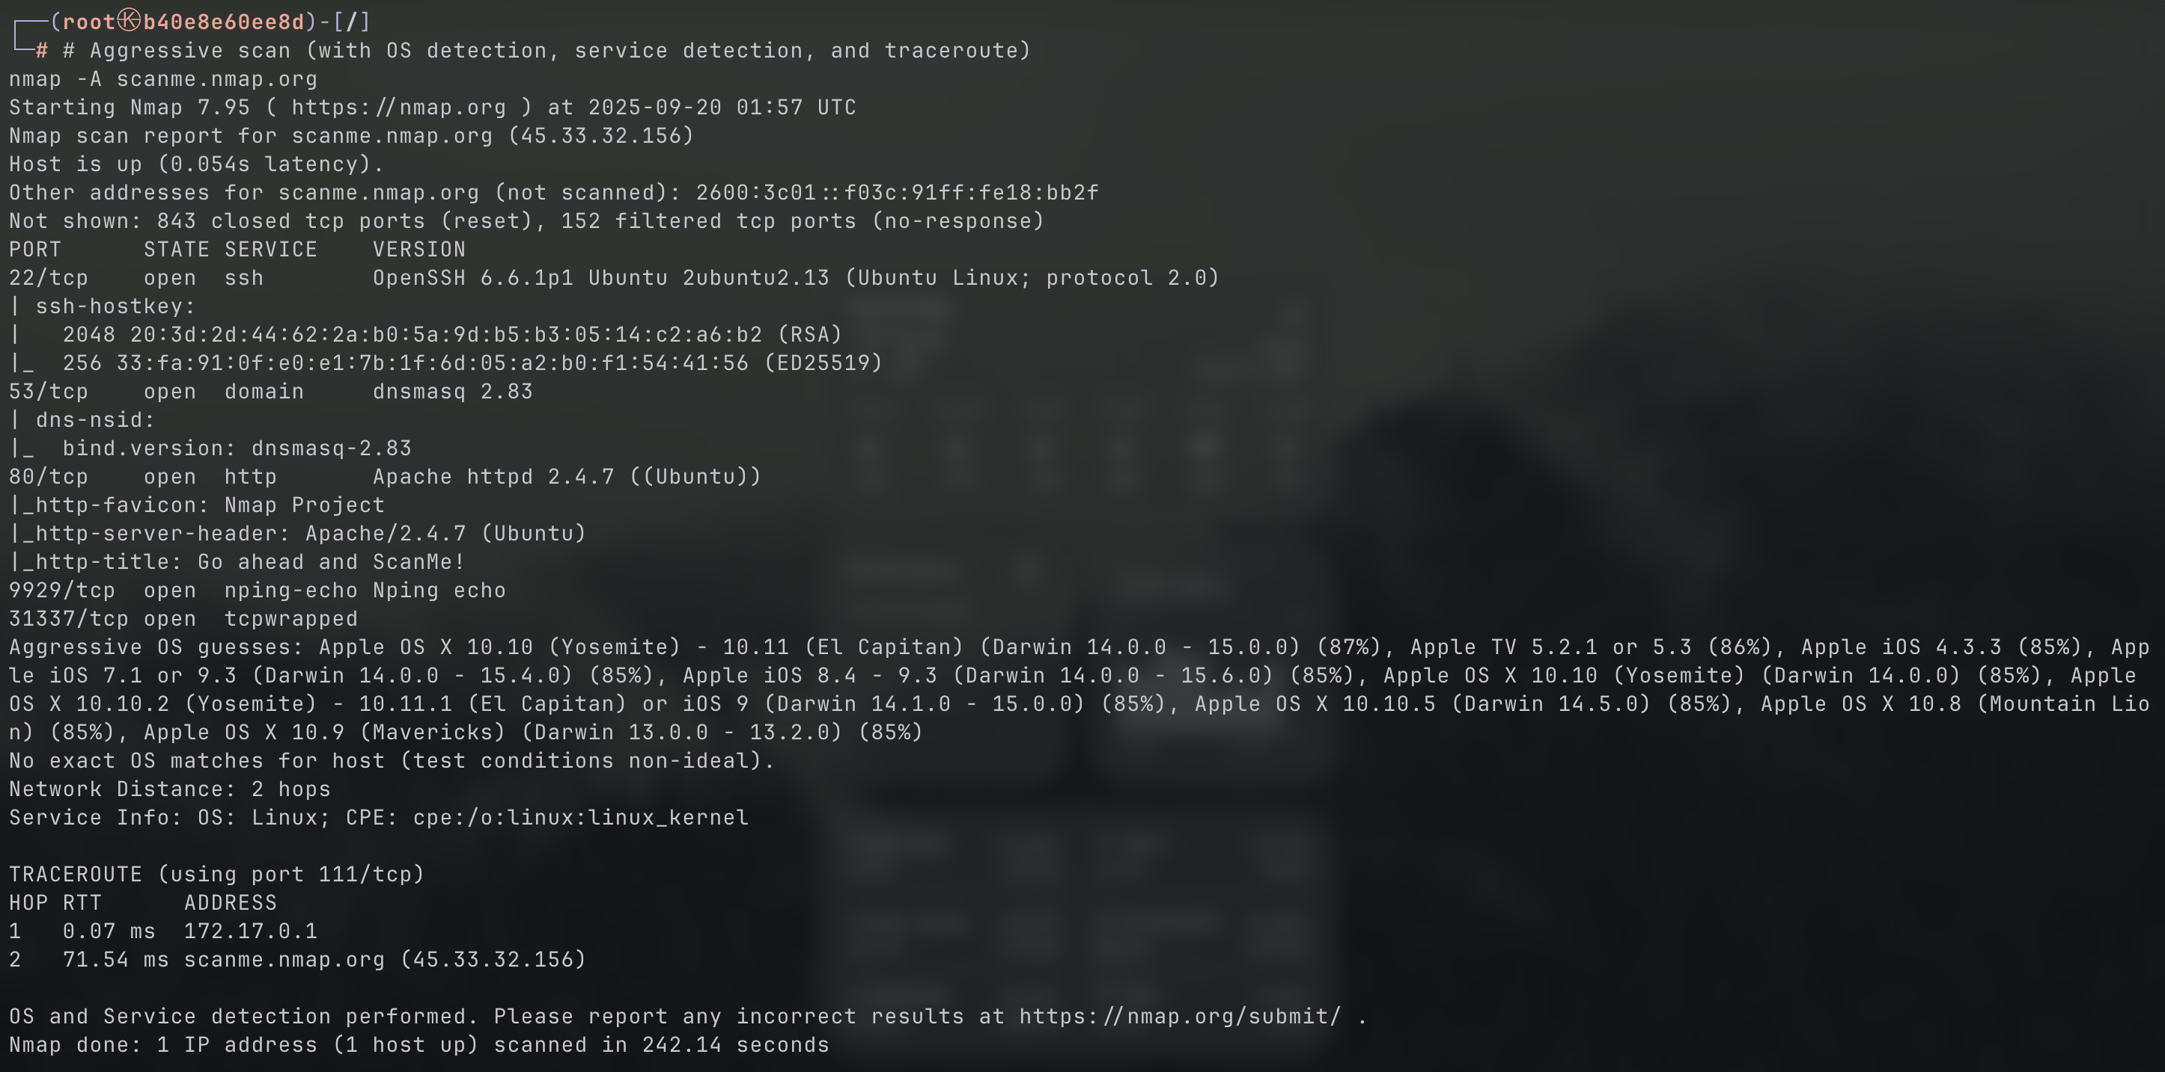

Process 3: Exploitation Basics

